**Assignment #2.**

Student: Ibraim Karakat

Group: SE-2433

**Project Report: Web Development Exercises**

**Based on the images provided, here is a report for a web development project.**

**Project Report: Web Development Exercises**

1. **Introduction This report summarizes the work completed for a series of web development exercises. The project includes three distinct parts, each focusing on fundamental HTML and CSS concepts to build simple, yet functional web pages.**
2. **Project Overview The project is structured into three separate exercises, each contained within its own directory (exercise1, exercise2, and exercise3). Each exercise directory contains an index.html file and an associated style.css file. The file structure is clean and well-organized, making it easy to navigate between the different parts of the project.**
3. **Key Features and Technologies Exercise 1: Simple Webpage Layout Goal: Create a basic webpage with a header, navigation bar, and sidebar.**

**HTML: The page is structured using**

**elements with IDs (header, navbar, sidebar) to define different sections. The navigation bar uses a list of links, demonstrating basic internal and external linking.**

**CSS: The stylesheet (style.css) applies a clear font (Arial), sets default margins and padding, and styles the main sections. The #header and #navbar elements are styled with specific background colors and widths, and the navigation links are floated to create a horizontal menu. This exercise demonstrates foundational CSS layout techniques.**

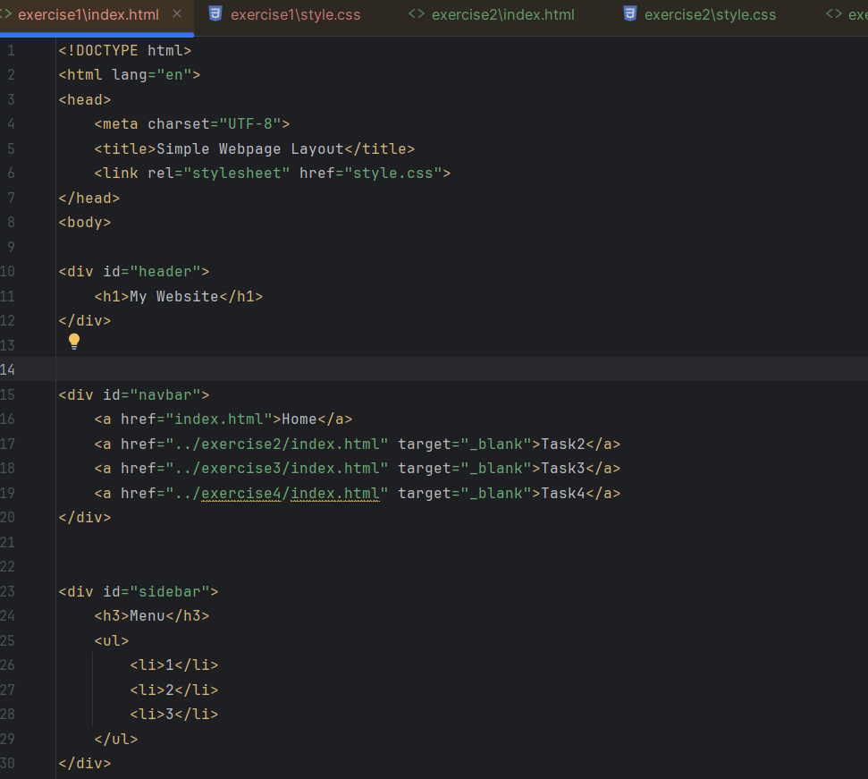

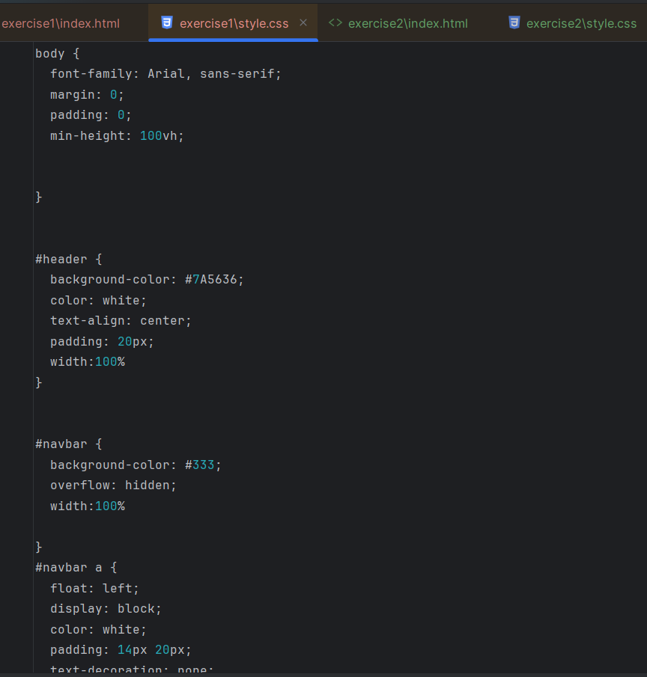

***Step 2.***

• **Goal:** Build a tribute page for Albert Einstein.

• **HTML:** The page uses a <h1> for the main title, an <img> tag to display an image of Einstein, and a <p> element for a brief biography. It also links to Google Fonts for custom typography.

• **CSS:** The stylesheet applies a more visually appealing font (Playfair Display), sets a linear gradient background, and styles the image with a border-radius and box-shadow for a polished look. It also uses a .content class to center the main content on the page, showcasing an understanding of basic content layout.

***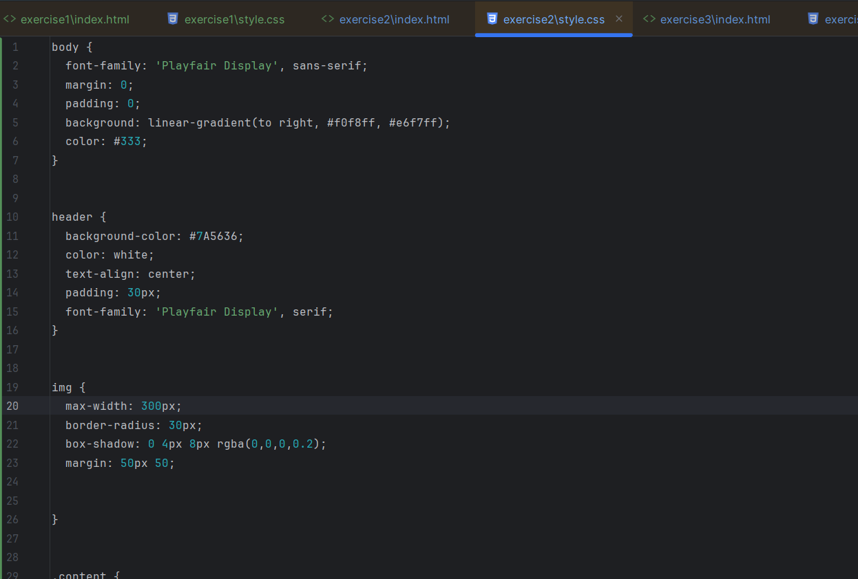*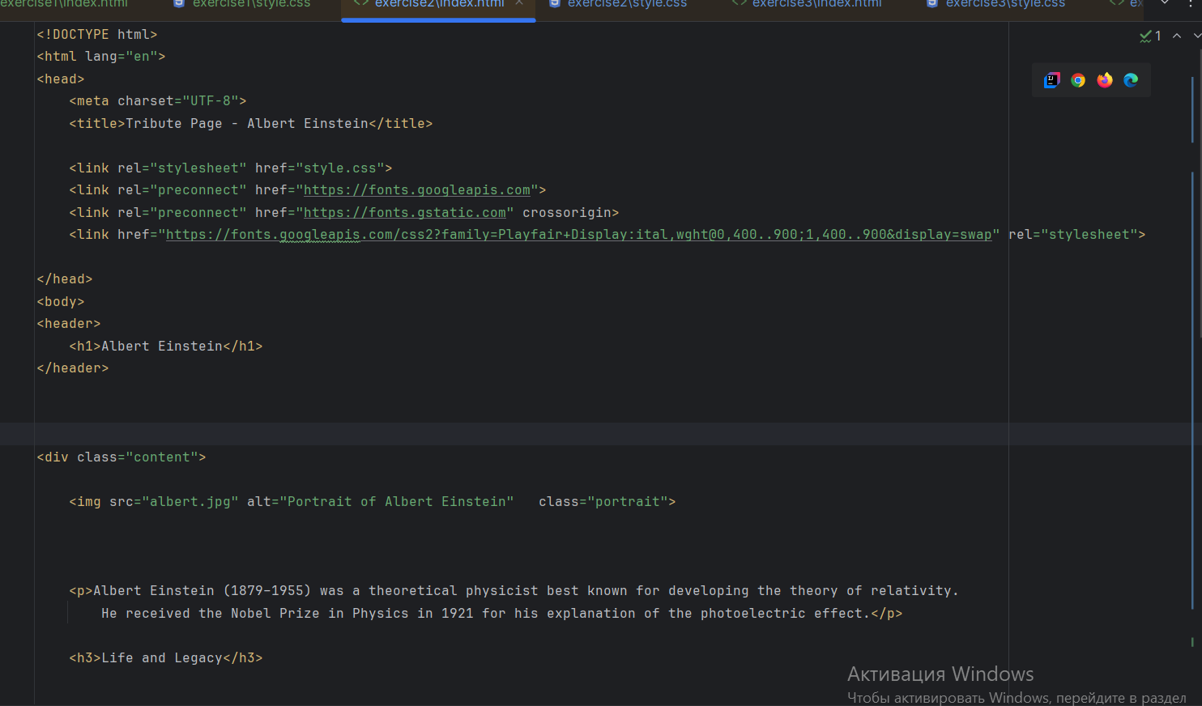**

***Step 3.***

**• Goal: Create a page with a feedback form and a styled table.**

**• HTML: The page includes an <h2> for the section title. The feedback form (<form>) includes various input types such as text, email, a dropdown menu (<select>), and radio buttons (<input type="radio">). Below the form, there is a basic HTML table (<table>).**

**• CSS: The stylesheet applies styles to the table to improve readability and appearance. The <table> is centered and styled with a collapsed border. The table headers (<th>) and data cells (<td>) have distinct background colors and padding. An interesting detail is the use of the :nth-child(even) selector to add a background color to every second row, which improves the readability of the table data.**

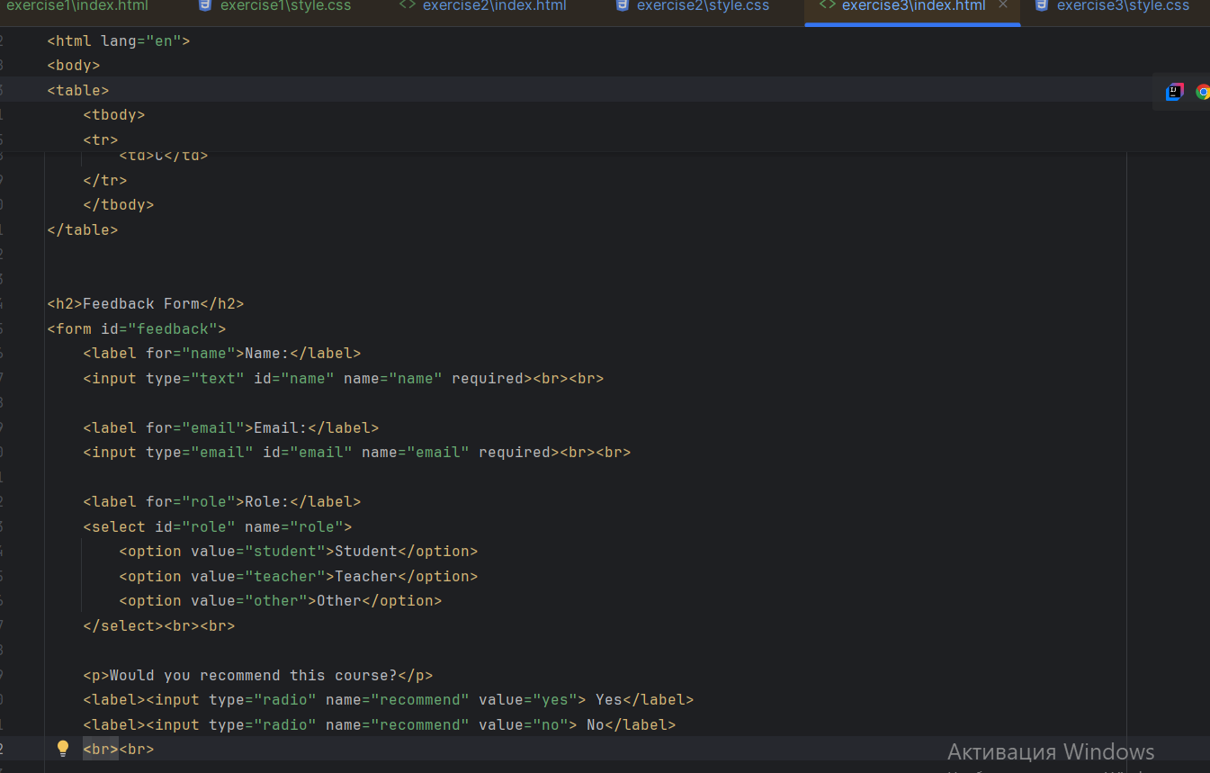

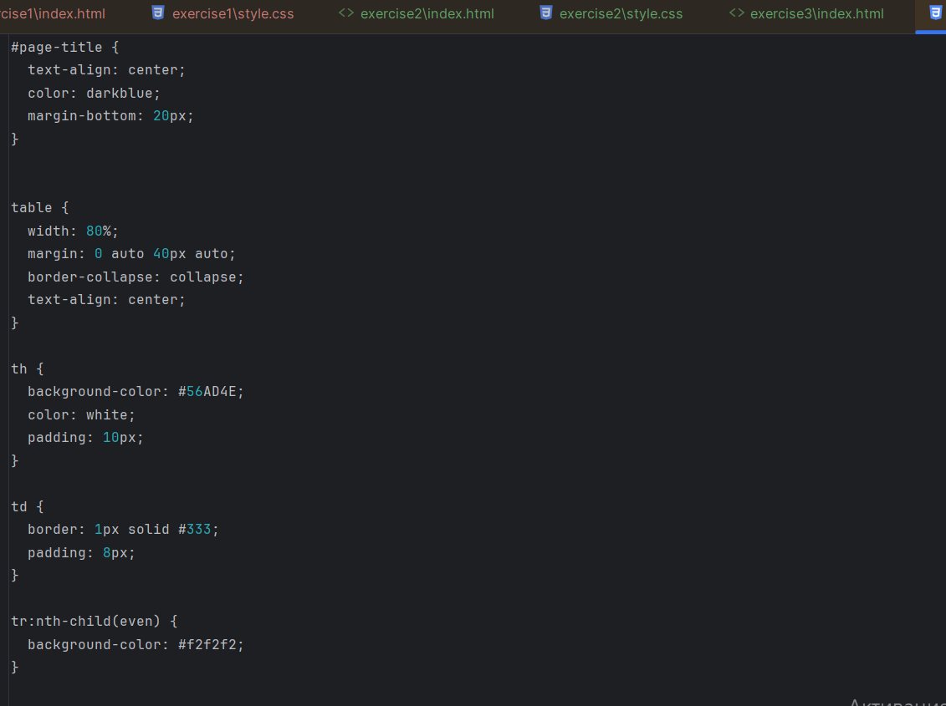

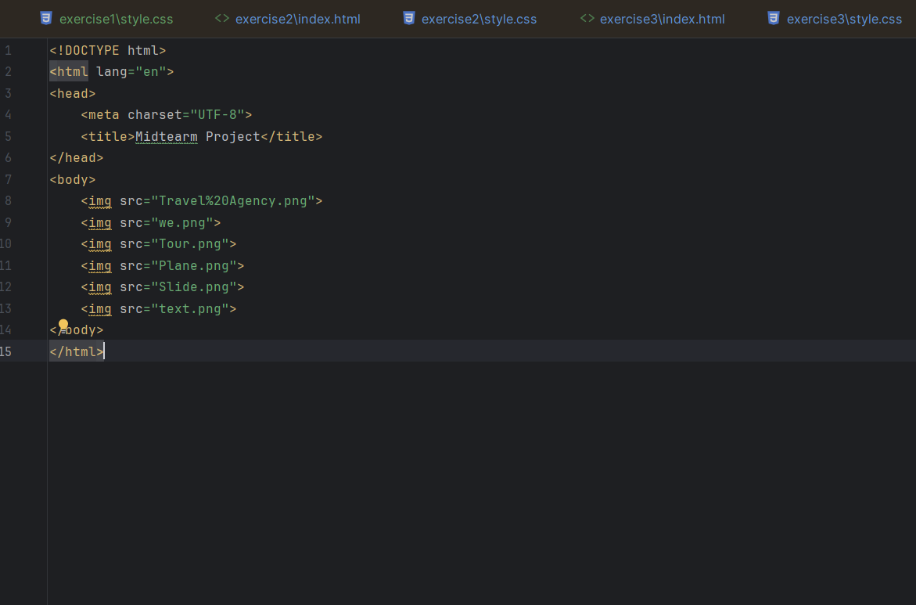

Conclusion

T he project demonstrates a solid understanding of core HTML and CSS principles. Each exercise successfully achieves its goal, showcasing proficiency in creating structured page layouts, applying visual styles, and building common web components like forms and tables. The use of separate files for each exercise and the clean code formatting indicate good development practices.

Live website link in github: https://github.com/Karakat177/WebTEch.git